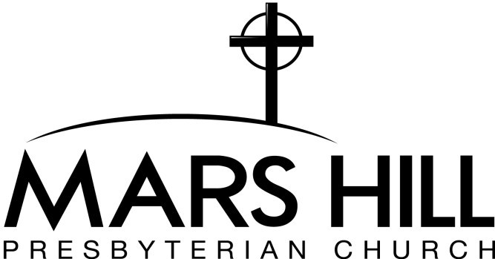AGREEMENT FOR USE OF CHURCH FACILITIES

Mars Hill Presbyterian Church, Inc. of Acworth, GA agrees to license use of its above mentioned facilities to the above named person/organization (licensee) for a **user fee of $ .**(Enter amount OR zero if no fee. For weddings or funerals, see respective policy in MHPC Policy & Contract Handbook.)

The number of persons attending the event shall not exceed the specified legal maximum occupancy number for each facility to be used. The space shall be clean upon departure and all furnishings shall be returned to their original location. Should there be any damages to the premises, the building, or its contents, the licensee shall reimburse Mars Hill Presbyterian Church, Inc., for any and all necessary repairs.

"Under Georgia law, there is no liability for an injury or death of an individual entering these premises if such injury or death results from the inherent risks of contracting COVID-19. You are assuming this risk by entering these premises."

Licensee agrees to abide by all On-Campus COVID-19 Policies and Protocols and acknowledges receipt of same.

The nature and purpose for which the facilities are to be used, are in accordance and agreement with the church doctrine of  
Mars Hill Presbyterian Church.

The Licensee hereby acknowledges that he/she has read the above agreement and agrees to its terms. The licensee also agrees to indemnify and hold harmless Mars Hill Presbyterian Church, Inc. (owner), as well as its officers, trustees, members, agents, and employees individually and jointly and severally from loss, damage or injury to persons or property resulting from use of the premises by the undersigned and/or entity the undersigned represents. The above agreement has been entered into on the day of (month), (year) by:

**LICENSEE: APPROVING AUTHORITY of Mars Hill Presbyterian Church:**

Signature:

Printed Name:

Signature:

Printed Name:

**FORM REV DATE: May 3, 2021**